prog 7313
POE PART 1 RESEARCH REPORT

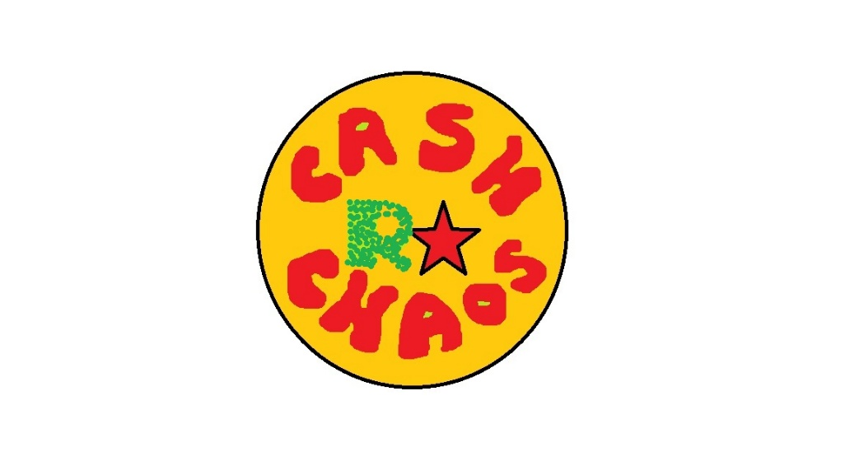

Bertha Wolvaardt (st10397382)
Cameron Lee Griffin (st10443441)
Christopher John Leonard Janse van Rensburg (st10434337)
Luan Gulamhussene da Silva (st10444978)
Regardt Estian Malan (st10434247)

1. Introduction
The following research report will be an analysis of the strengths and weaknesses of three personal budgeting apps. Cashew Expense Budget Tracker, You Need a Budget and The Budgeting App will be compared to determine their standard- and innovative features. Potential pitfalls, in terms of features and designs, will be identified. To that end an overview, the strengths and weaknesses, and innovative features of each of the applications follows. Furthermore, all these criteria will be compared and summarized in a list of most desirable features.

2.1 Overview of the App: Cashew Expense Budget Tracker
Cashew is a personal budgeting app. Cashew helps users set spending limits, saving goals, budgets and track expenses (Teckwise, 2025). Cashew is focuses more heavily on a visually appealing interface than its competitors (Teckwise, 2025). Cashew also helps users visualize their money with sleek, attractive and modern graphs that are customizable and display on the home screen (Teckwise, 2025).
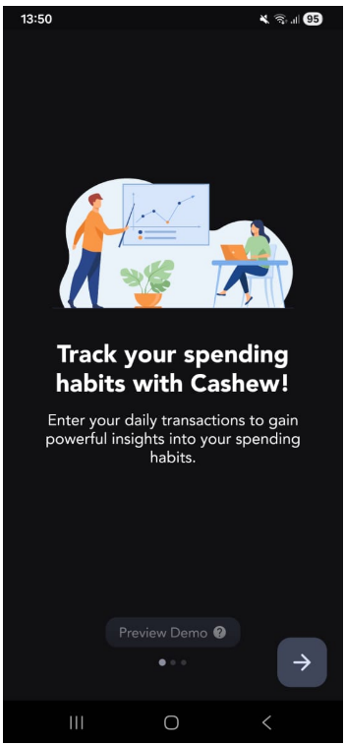
Figure 1: First Screen Upon Opening the App for the First Time (Cashew).
The app starts with an optional tutorial of the main features of the app and how to use the app. It educates the user by making use of dummy data, so that the user will see how to use it intuitively once it is set up.
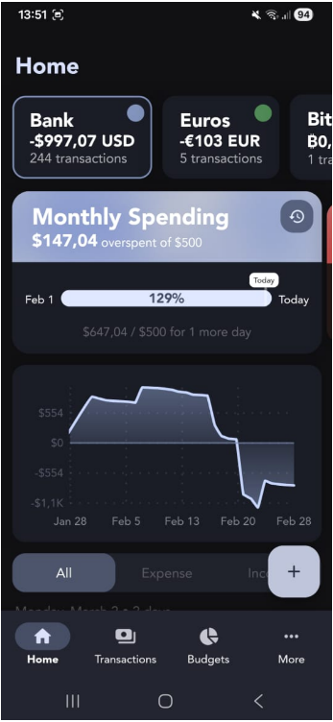
Figure 2: Navigation Bottom Bar (Cashew).
The bottom navigation bar has only four options, making it easier to reach and allow them to navigate throughout the app effectively.

Figure 3: Home Screen (Cashew.)
Home Screen covers various important features of the app including the different accounts at the top.
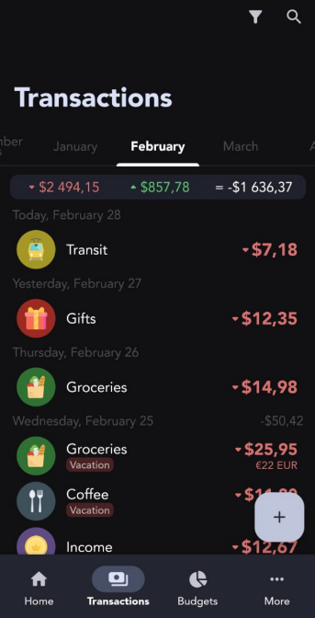
Figure 4: View All Transactions Screen (Cashew).
With the Transactions View the user can track their expenses according to the different Categories that they set up previously.
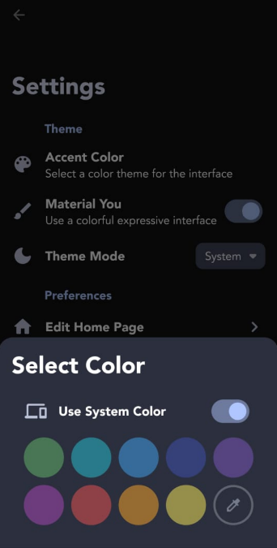
Figure 5: The Settings and Customization Options (Cashew).
The app offers various personalization and customization settings, such as colour and theme selection.

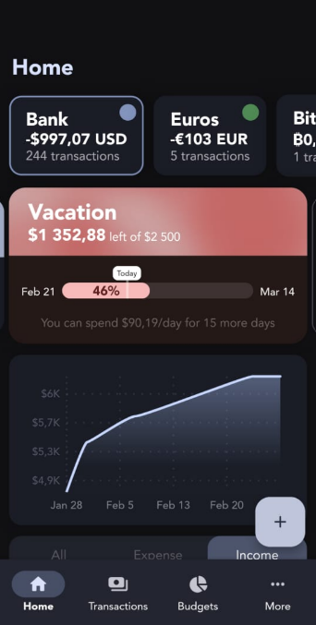
Figure 6: Income Tracker (Cashew).
Being able to toggle between Income and Expense Views that are graphically displayed in this app is one of its best features.
Cashew Strengths
- Feature and customization rich (Dapper App Developer, 2024).
- Powerful visual aids and graphics (Dapper App Developer, 2024).
- Has a strong focus on interface and ergonomics (Teckwise, 2025).
- Has a helpful demo when launched.

Cashew Weaknesses
- Terminology used is sometimes unclear (see Cashew Budgeting App Getting Started, 2025).
- Abundance of options can be overwhelming for new users (see Cashew Budgeting App Getting Started, 2025).
- Requires a lot of setup (see Cashew Budgeting App Getting Started, 2025).
- Only tracks personal finances, not investments (see Cashew Budgeting App Getting Started, 2025).
Cashew Innovative Features
- View a history of all spending periods with custom filters (Teckwise, 2025).
- Data Backup and Security features with Google Drive (Dapper App Developer, 2024).
- Emojis can be used as category icons (Dapper App Developer, 2024).
- Abundance of visual aids, pie charts, and graph (Teckwise, 2025).
- Bill Splitter (Teckwise, 2025).
2.2 Overview of You Need a Budget
You Need a Budget is a zero-based personal budgeting app. It prompts the user to disclose their entire income and allocate it to expense categories before it is spent (Feasible Creative,2024). It helps keep the user more accountable and promotes awareness of expenses by making the user explicitly allocate income (Feasible Creative,2024).
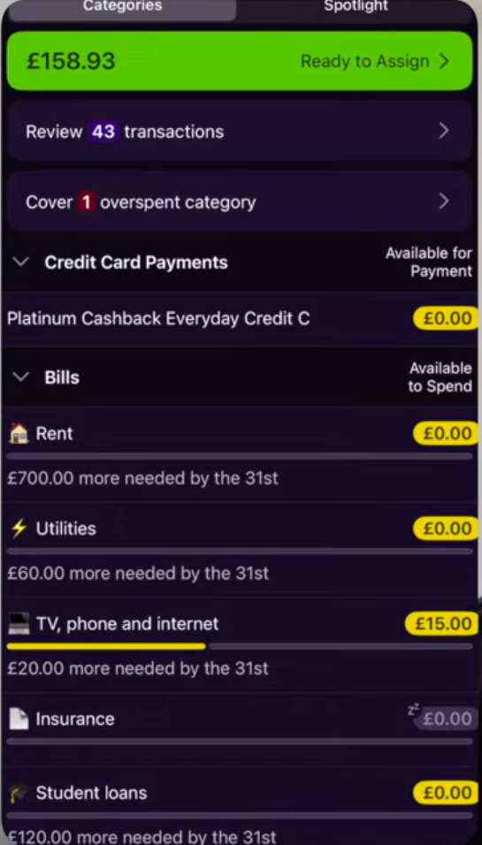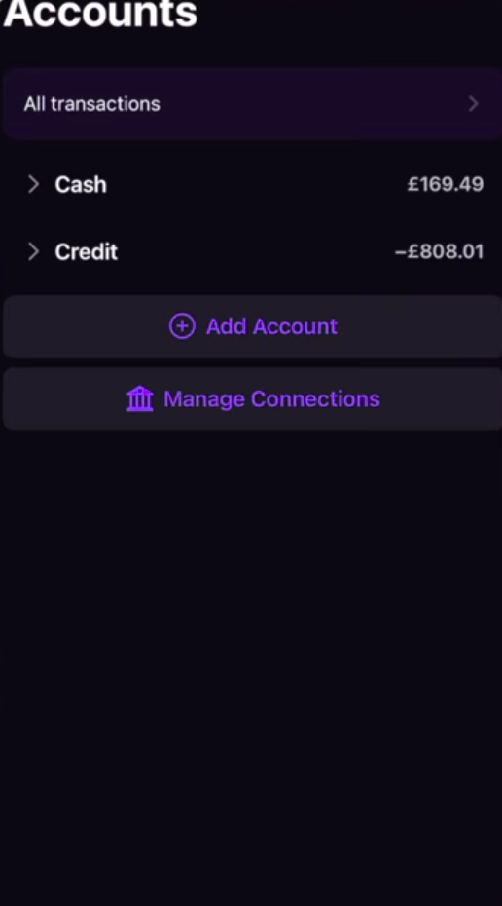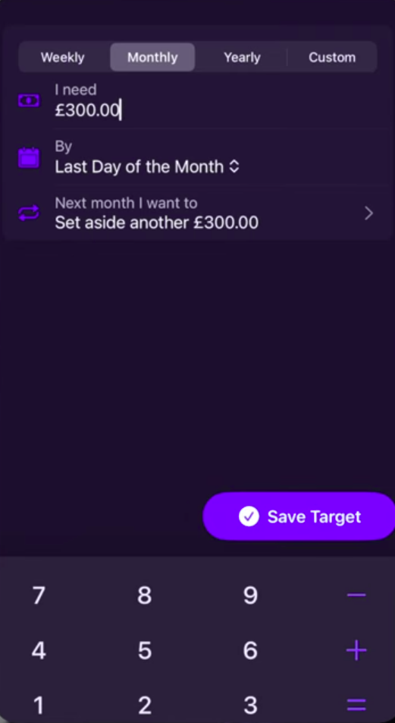
Figure 7: Expense Categories (YNAB).
Users check their plan before spending to ensure they spend within set limit.
All available funds get budgeted towards an expense category based (Feasible Creative,2024).

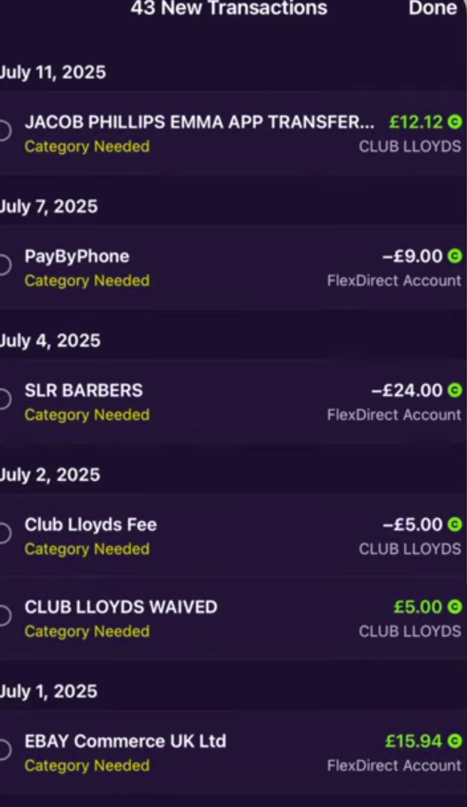
Figure 9: Accounts Screen Showing Transactions (YNAB).
Connected accounts where income and expenses come from.
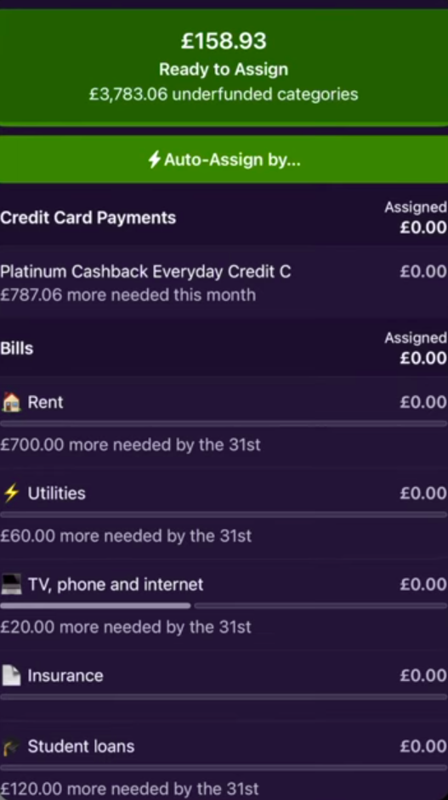
Figure 10: Setting a budget screen (YNAB).
Setting amount and frequency of budget cycle.

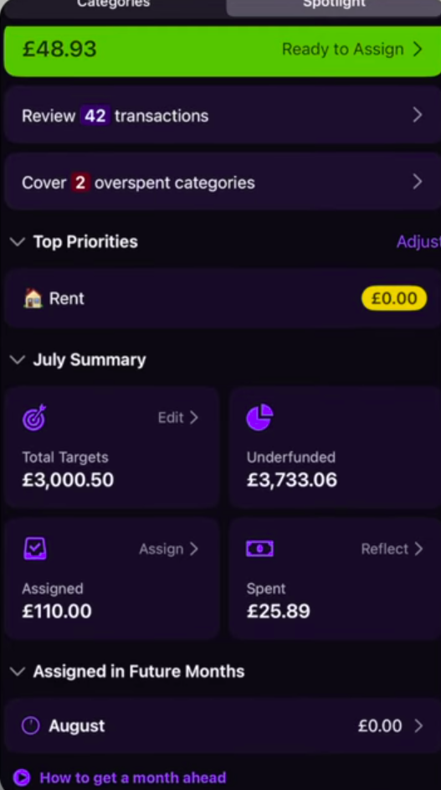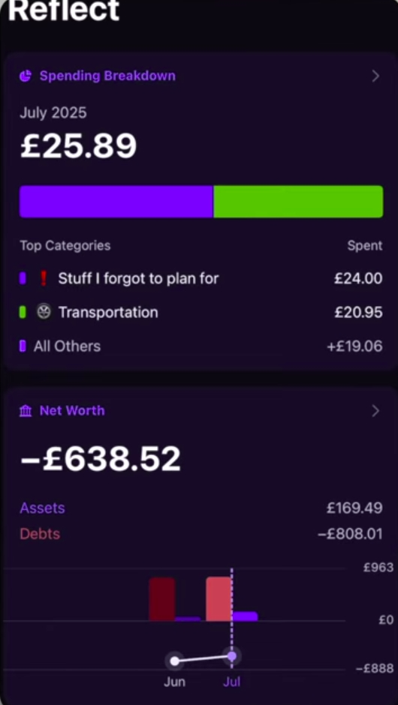
Figure 11: Spotlight screen – reports and summaries of expenses (YNAB).
You Need a Budget: Strengths
- Allows account synchronizations across multiple devices and banks (Feasible Creative, 2024).
- Allows access via multiple platforms (mobile and web) (Feasible Creative, 2024).
- Accommodates flexible budgeting for large expenses or overspent categories (Feasible Creative, 2024).
You Need a Budget Weaknesses
- No support of investment- or real-time tracking (Feasible Creative, 2024).
- App does not guide users through how to use it (Feasible Creative, 2024).
- Slow loading speed. LUAN – PUT REFERENCE HERE
You Need a Budget Innovative Features
- Common Goal: multiple users can add funds to a shared account (Feasible Creative, 2024).
- Forsee expenses: user sets budgets for large future payments (insurance, renews, payments) automatically the app creates a budget spread across a period to allow user to budgeted (Feasible Creative, 2024).
- Public API: large pools of user made wrappers and integrations available. Allows YNAB to integrate into other tools and users can create.
- Unique gamification features: Money age – income is timestamped. The longer the income stays in the account the more it “ages” (Feasible Creative,2024).

2.3 Overview of The Budgeting App
The Budgeting App is a simple personal budgeting app that has been designed to minimize steps for people to track their income, expenses, and transactions between accounts (Gooch, 2025). The Budgeting App divides personal budgeting into books. Books are top level containers where you can log your budgets and track your savings and debts. Your book shows your actual balance across accounts including having an advanced search to find transactions.
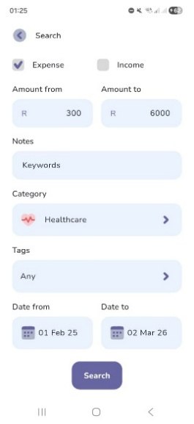
Figure 1 Books Advanced Search (The Budgeting App)
To log transactions conveniently the app focuses on capturing incomes and expenses with the amount and a category. Other optional meta data can be added such as notes, tags, reminders, and transaction recurrences.

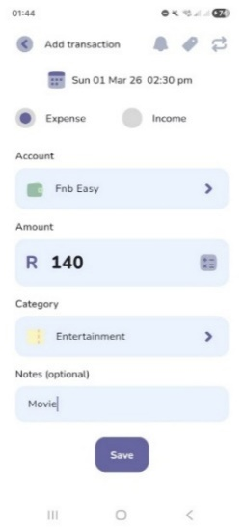
Figure 2 Log Transaction (The Budgeting App)
A focus is placed on your how often you get paid (The Budgeting App, [s.a.] a). You can view your book with the actual balances of your accounts and a grand total for your book. Or with the forecast view that also shows expected finances related to upcoming bills & incomes (TBA Jeremy, 2024).

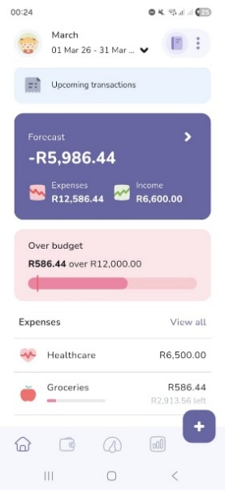

Figure 3 Budget Forecast (The Budgeting App)
The onboarding process guides the user to set a budget per category of expected expenses and set goals for reaching target incomes. Challenges continue by letting the user discover how to create trackers for saving and debt management.

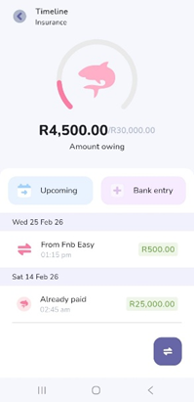
Figure 4 Loan Tracker (The Budgeting App)
Users collect achievements where the app encourages users to stay consistent with streaks, stay disciplined and consistent. Challenges are fallible meaning there are game like stakes when not completing a challenge.

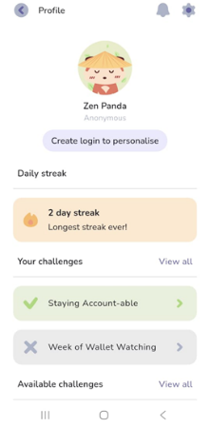
Figure 5 Profile Challenges (The Budgeting App)
The app has various free and paid analysis tools to help you analyze your money.

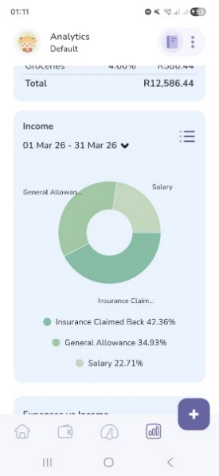
Figure 6 Income Pie Chart (The Budgeting App)

The Budgeting App: Strengths
- Simple and Intuitive user interface (The Budgeting App, 2022).
- Supports cloud sync with access on multiple devices (Natile, 2024).
- Onboarding and clickable pop-ups helps the user discover app features.
- Can customize views to show less details like income or the remaining budget.
- Data can be exported as CSV file.
- Numerous analysis tools.
The Budgeting App: Weaknesses
- Cannot import history via a CSV file.
- Does not automatically synchronize transactions with your bank.
The Budgeting App: Innovative Features
- Biometric App lock.
- Gamification for on boarding and fallible challenges.
- Can export data to CSV file.
- Set reminders to review budget.
- Built in calculator on logging page.

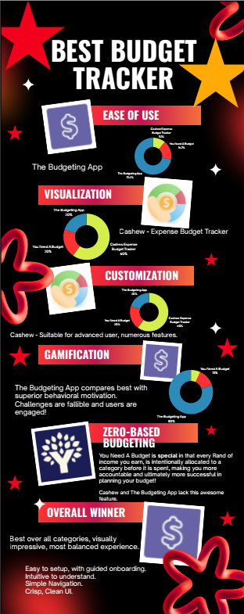
4. Best Features List to Include in Cash Chaos App
From our research on Cashew, You Need a Budget and The Budgeting App, we have identified the following desirable features to include in our own app:
- Multiple Wallet Support
For Example: FNB Cheque, Capitec Savings Account, Standard Bank (Credit Card) and Cash.
The app must be able to handle multiple accounts as well as negative account balances, overdrafts, and accounts that are in debt such as credit cards.
- Multiple Currency Support
For Example: This will allow for an account in the wallet to be expressed in foreign currency and payments or withdraws can be made using the exchange rate and viewed under wallet/accounts.
- Bill Splitter
For Example: A restaurant bill can be easily split between any number of guests and include a tip amount.
- Forecast View
For example: Seeing the expected amounts for a date in the future, this will work by predicting expenses and incomes of upcoming subscriptions and recurring costs such as subscriptions, rent, bank fees and gym memberships.
- Duplicate Expenses
For example: This helps the user to easily add an expense that is often made but is not a subscription, like a favourite R35.00 coffee at Starbucks or R 500.00 petrol purchase made. This aids the user to add an often-repeated expense quickly.
- Ability to Group Accounts
The user can make a “parent” account that can have “children” under it. For Example: Vacation can be a “parent” account while the associated costs such as food, accommodation and activities can be “child” accounts.

5. Conclusion
Our research has shown that what makes a great personal budgeting app is the app’s ability to aid the user with easy to understand visualization and a convenient way to keep track of ongoing daily expenses. Thus in the design of our personal budgeting app, Cash Chaos, we have decided to implement simple, bright-and-friendly visuals to make understanding easy and convenient.
Our research has shown that, users prefer engaging with an app with fewer features, as this helps them to navigate and focus on the core functionalities of the app. Thus in Cash Chaos’s design we have decided to prominently display core features and compartmentalize additional features under menus to reduce visual clutter.
Additionally, our research has shown that gamification is an effective feature for keeping users engaged. Thus in Cash Chaos’s design we have implemented a several gamification features such as streaks and achievements to keep users engaged.
From our research we have identified the following desirable innovative features: Multiple Wallet Support, Multiple Currency Support, Bill splitter, Forecast View, Duplicate Expenses and Ability to group Expenses. Thus in Cash Chaos’s design we have decided to include all these innovative features.
In conclusion, when taking the above-mentioned into consideration Cash Chaos’s design will be appealing, intuitive to use, engaging and encourage consistent use through gamification. Making it enjoyable and rewarding to use.

6. References
App Review: Cashew, finally a budget app for you. 2025. YouTube video, added by Teckwise [video online] Available at: https://youtu.be/BG8Z2DTAoLg?si=yNKX5eGLhAHHka3S [Accessed 28 February 2026].
Cashew Budgeting App Getting Started. 2025. YouTube video, added by Rebecca Sowden. [video online] Available at: https://youtu.be/UJ4mDc_WJ24?si=-RkZgGRrgVUFdSBn [Accessed 28 February 2026].
Cashew-Expense Budget Tracker. 2024. Dapper App Developer. Version 5.4.4. [App]. Available from Google Play [Accessed 28 February 2026].
Feasible Creative,2024.YNAB Budget App: What I Wish I Knew Before Starting.[video online] Available at: https://www.youtube.com/watch?v=mqB_Vu2_le0 [Accessed 24 February 2026].
Gooch. C, 2025. Young couple design their own budgeting app, save enough to buy a house. [Online] Available at: <https://www.thepress.co.nz/business/360564404/can-budgeting-really-be-fun-two-app-developers-think-so> [Accessed 1 March 2026].
Jacob Phillips,2025.YNAB Tutorial & Honest Review (2025) | Complete Setup Guide & Pro Budgeting Strategies.[video online] Available at: https://www.youtube.com/watch?v=6smi9S8Rm7s&list=TLPQMjQwMjIwMjaQEQBlrtAcdA&index=3 [Accessed 24 February 2026].
Natile, 2024. The Budgeting App. [Online] Available at: <https://betalist.com/startups/the-budgeting-app> [Accessed 1 March 2026].
TBA_Jeremy, 2024. How to use the roll-over budget feature. [Reddit] 1 December. Available at: <https://www.reddit.com/r/thebudgetingapp/comments/1h4d831/how_to_use_the_rollover_budget_feature/?utm_source=share&utm_medium=web3x&utm_name=web3xcss&utm_term=1&utm_content=share_button> [Accessed 1 March 2026].
The Budgeting App, [s.a.]. Plans. [Online] Available at: <https://thebudgeting.app/plans/> [Accessed 1 March 2026].
The Budgeting App, [s.a.]. The quick way to budget. [Online] Available at: <https://thebudgeting.app/> [Accessed 1 March 2026].
The Budgeting App, 2022. Budgeting App - Spend Tracker. Version 5.9.8. [App] Available at: <https://play.google.com/store/apps/details?id=com.thebudgetingapp.thebudgetingapp&pcampaignid=web_share> [Accessed 1 March 2026].

